Solution 3

Erd shows that it has customer, workorder, task are regular entity customer requests workorder for set of tasks .Customer has CustId(primary key) ,CustName,CustAdd,Workorder. WorkOrder has OrderNo,createdate,reqdate,completedate,customer,superviseemp,workadd,task attributes. Task has TaskId,TaskNAme,HourlyRate,EstHour attributes. Customer requests to workorder for set of tasks workorder records set of tasks .Tasks check status of completion from status entity containing statusId for each status,actual hours,completiondate,taskstatus (not started,in progress,completed).Status entity is weak .It depends on task .A task has more than one status. A status should be given to task.

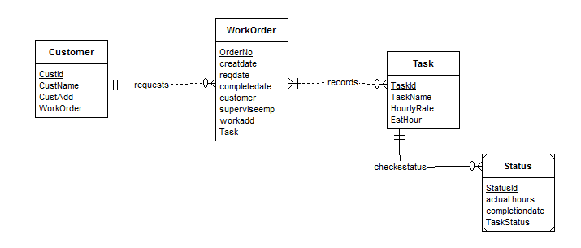

Above ERD is complete according to problem .Now this ERD is redefined with some new entity to meet requirements;

1. Ever workorder uses a list of Materials.Material Entity is made with attributes MatId,MatName,Matcost. It has M-N relationship .

2. Material used in each workorder includes estimated quantity and actual quantity .Weak Entity MatCollection is made to check the quantity used of material . Relation ‘used’ has 1-M relationship to check material quantity in each order.Relaqtion ‘appear’ informs ‘material’ entity to provide material for completing task.

3.Weak Entity ‘Esthour’ is made to check the estimated completion of task which depends on workorder and task both

**Redefined ERD**

